# CIS11 Final Review Part 1: Chapter 1 – 6

1. What is the binary equivalence of decimal 20510?
2. Convert hexadecimal 4E2C16 to binary.
3. Determine the twos’ complement for hexadecimal 8A216 that is stored in a WORD size storage location. Provide answer in hexadecimal.
4. Determine the twos’ complement for decimal 811. Provide answer in binary.
5. Solve:

1 1 1 1 1 0 0 1

+ 1 0 0 1 1 1 0 1

1. Solve:

1 0 0 1 0 1 0 1 1

* 1 0 0 0 1 0 1 0 1

1. Find the result for:

1 0 1 1 1 0 0 1

OR 1 0 1 1 0 0 1 0

1. Solve and provide answer in WORD size;

1 1 0 1 1 1 1 1

NAND 1 1 1 1 0 0 1 0

1. What type of architecture, under ISA classification, directly uses the memory, instead of a register file to hold data and instructions?
2. Which architecture requires more complex hardware to implement instructions, which are which are generally register to register operations?
3. True or False:

Directive is built up from discrete statements or instructions that requires particular registers for arithmetic, addressing, or control functions, memory locations or offsets, addressing modes used to interpret the operands.

1. What type of MOS transistors pulls voltage up when receives zero inputs?
2. What type of sequential circuit systems coordinates signals and control data movement?
3. Fill in the blank: A circuit that changes a code into a set of signals is known as a ___(blank).
4. What type of circuits is used to trigger transitions from one state to another in a state machine?
5. Use Multibit representation to denote the highlighted bits:

D[l:r] denotes bit l to bit r, from left to right

1111010010100111

1. Fill in the blank: A transistor that performs the basic logical functions and considered to be the fundamental building blocks of digital integrated circuits is known as __(blank)__.
2. What are the differences between combinational and sequential circuits?
3. Which of the following logic gates represents NAND?
4. 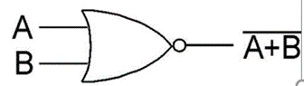
5. 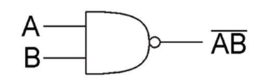
6. 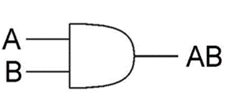
7. In a combinational circuit of a processor, which component permits input and output selection?
8. Which assembly operation writes a value to a memory location?
9. In a processor, which component is considered as a small, temporary storage of the processing unit?
10. In addressing mode, where can an operand be found?
11. Identify the operational instructions in LC-3.
12. What are the conditional codes of LC-3?
13. Which instruction stores the content from Source Register onto a memory location, allowing instruction to access full memory address space?
14. Write the instructions to load address, x3105 from label ADD1 onto R1 without accessing the memory.
15. Write LC-3 code to calculate: z = x – y, for x is 9 and y is 5.
16. Describe “Systematic decomposition.”
17. Which LC-3 instruction has no limitation on where the next instruction to be executed must reside?
18. Given the opcode, identify the appropriate instruction.
19. opcode = 0001
20. opcode = 0101
21. opcode= 1001
22. opcode = 0110
23. opcode = 1011
24. Identify the appropriate TRAP vector, given the description of each system call.
25. A character input
26. Halt execution
27. Write strings pointed by R0 on screen.
28. Get character from keyboard